WOMEN'S OPEN FORUM
You are invited to an intriguing afternoon ~
spent with interesting women
Mission statement: To inspire women of all ages to discover their full potential.

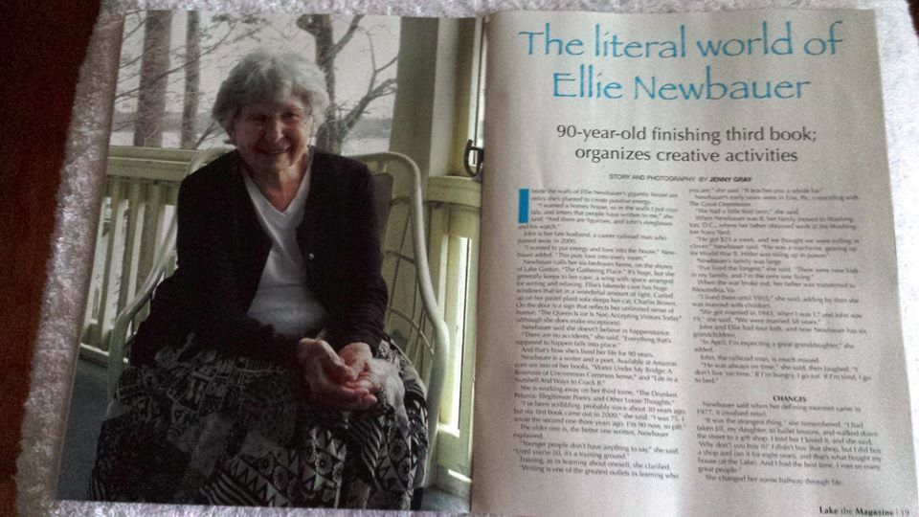
3rd Saturday of each month 1:00 to 3:30PM
The Gathering Place” on Lake Gaston
115 Magnolia Ct. Wildwood Point, Littleton NC 27850
July 18 special meeting this month: Open discussion on:
"Even though your past has a big influence on your decisions, it doesn't own you, nor are you bound by it."
Coming. . . .Aug 15, 2015 TBA
~ Inquiries: Ellie Newbauer: ellienewbauer@gmail.com
*$10.00 Donation Come, Join Us!

